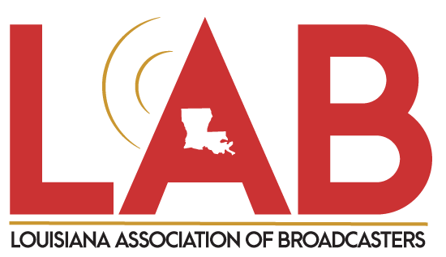
2023

MONTHLY REPORT
NCSA/PEP SPOTS AIRED

Louisiana Army National Guard

REPORTING STATION CALL LETTERS: _____________________ _____________
(Please submit a separate report for each station/duplicate this form, if necessary)

REPORT PREPARED/SUBMITTED BY: ____ _____________

EMAIL: ___________________________________________________ __________________________
TELEPHONE NUMBER: __________________________ _______________________________________
MAILING ADDRESS: __________ ________________
CITY/STATE: __ZIP: _ _______

*** Were spots ‘streamed’ on station’s website? (Circle One) YES NO

I certify that the above-named station aired spots for the LANG as follows:

January 2023

MONTH # SPOTS AIRED VALUE OF SPOTS

January Totals: $

SIGNED: Date:

